Bylaw 1. Campus Closure Procedures

Under the circumstances that Oklahoma State shuts down for any Emergency reason, the following procedures will be met.
Section 1.1 The following is a list of exceptions for the Executive Board during a Campus Closure

- Executive Board members will not be required to come into the office to complete their assigned number of office hour tasks as outlined in Article 4, but will instead have the option to complete them at home by completing a list of tasks each week as assigned by their Advisor and or GA(s)
- Meetings for the Executive Board during a Campus Closure will be determined by the Executive Board during their term. An online option will be made available for those exec members that would like to utilize it, and in person attendance will not be mandatory.
- If an Executive Board member tests Positive for COVID-19 and still feels well enough to do so, they will be expected to still participate to the best of their abilities in SUAB functions from home. This includes but is not limited to: Training, Online Events, Meetings, Ect.

Section 1.2 The following is a list of exceptions for the General Board during a Campus Closure

- The General Board will not be expected to show up to help at events that take place in person, if they don’t feel safe to do so, as long as there is communication with their Committee Director, or another member of the Executive Board
- Alternative ways to participate in events will be made available for those General Board members in case by case situations.
- Meetings for the General Board during Campus Closures will be moved to an online format, for both General Board meetings and Committee meetings.

Section 1.3 The following is a list of exceptions for Tabling during for COVID-19

- Before tabling, the temperature of all student and staff volunteers is to be taken
- Each volunteer helping at a tabling event must wash their hands before and after the tabling
- Face coverings must be worn at all times
- All handout items are to be sanitized before handing out, or in individual packaging
- Swiping in and other attendance methods must be done in such a manner that nothing is handed directly between two people
- All SUAB and ACE tabling/ walk by events will have social distancing signage for participants to follow
- ACE will provide 6 foot markers to help with social distancing at events
- Sanitation of equipment will be mandatory after every event

Bylaw 2. Executive Board Hiring Process Exceptions

Under the circumstances that the executive board is unable to be filled through the regular hiring procedures as stated in the constitution, the following procedures will be met.

Section 2.1 The following is a list of exceptions to the requirements for eligibility of executive board members (excluding President, VP of Programming, and VP of Arts).

- Applicants will not be required to have been a part of the Student Union Activities Board for a semester.
- Applications will be marketed to the campus as a whole and not specific student groups or populations.

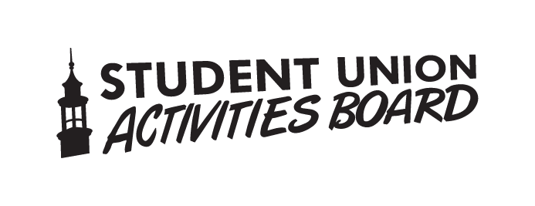
Updated October 2020

